

**Fleet Management System**

In Partial Fulfilment of the Requirements for the course

CSCC20 - Object Oriented Programming

Submitted by:

Arbie Delizo

Maria Liza Paano

Submitted to:

Mr. Jessie Lagrosas

October 14, 2019

**TABLE OF CONTENTS**

**INTRODUCTION 1**

**REQUIREMENT ANALYSIS 2**

**FUNCTIONAL 2**

**NON-FUNCTIONAL 2**

**USE-CASE ANALYSIS 3**

**USE-CASE DIAGRAM 6**

**CLASS DIAGRAM 10**

**SEQUENCE DIAGRAM 15**

**LOGIN 15**

**EMPLOYEE 16**

**BOOKING 17**

**RESERVATION 18**

**DRIVER 19**

**MAINTENANCE 20**

**REPAIR 21**

**PAYMENT 22**

**API 23**

**APPENDICES 24**

**Appendix 1: DATABASE DOCUMENTATION 24**

**Appendix 2: CURRICULUM VITAE 25**

**INTRODUCTION**

The Fleet Management System aims to address the problem of our client in their business which is booking and we added other features that does not only address their booking problem but also manages their vehicles and keeps track of there their vehicle’s maintenance and repair. The system also address there booking problem, and we also added a reservation feature in our system it can also add new employee and driver.

Some features of our system also include adding, deleting, and updating. This also tracts the maintenance and repair of the vehicles, this also includes the booking and reservation of the customer. The system solved the problem of our client which is to book and reserve vehicles (vans) for the customers.

**REQUIREMENTS ANALYSIS**

* **Functionalities**
* The system must allow the admin to make a booking and a reservation. The system would save the booking and reservation information in the database and would display the data in the table.
* The user asks the customer the start date and the end date so that the system would know the length of the booking.
* This would also keep track of the schedule of the vehicle that would go maintenance.
* The system also allows the employee to add the vehicle that needs to be repair and the type of repair the vehicle needs to fix.
* The system allows the employee to add new driver.
* **Non – Functionalities**
* The system is pleasant in the eyes of the user.
* The system helps the admin to manage and organize the booking and reservation of the customer.

**USE-CASE ANALYSIS**

**Use-Case 1**

**Title:** User Login

**Description:** This is to ensure that the user is register in the system. The employee needs to input his/her username and password first in order for him/her to be connected to the system.

**Actors:** Admin and Employee

**Pre-Condition:** The user must be register in the database

**Post-Condition:** The admin or the employee will be able to modify the information in the database.

**Use-Case 2**

**Title:** Add Employee

**Description:** If the employee or the admin wants to add new staff in his/her system he/she needs to input the credentials of the new employee.

**Actors:** Employee or Admin

**Pre-Condition:** The employee/admin needs to login to the system.

**Post-Condition:** The admin could also view the employee that was already in the system and the new employee that was added in the system.

**Use-Case 3**

**Title:** Add Booking

**Description:** If there are new customers that want to make a booking, the employee needs to input all of their credentials, such as the names, start date, end date and how many passengers would ride the vehicle.

**Actors:** Employee and Customer

**Pre-Condition:** The customer will make a call or it can be a walk in transaction to make a booking.

**Post-Condition:** The employee could view all the booking in the table.

**Use-Case 4**

**Title:** Add Reservation

**Description:** If the customer only need to reserve but still wasn’t sure if he/she would book the vehicle, they can just reserve it. The employee then fill-in the information needed for the reservation.

**Actors:** Employee and Customer

**Pre-Condition:** The customer will make a call or it can be a walk in transaction to make a reservation.

**Post-Condition:** The system also allows the employee to delete and to cancel the reservation. The admin could then view the reservation made by other customers and also update.

**Use-Case 5**

**Title:** Add Driver

**Description:** If there is new driver/s, the employee then gets all the credentials of the driver to save it in the database.

**Actors:** Employee and Driver

**Pre-Condition:**

**Post-Condition:** The admin could see the existing drivers in the system and if there are some revisions/update the employee could just click the update button.

**Use-Case 6**

**Title:** View Maintenance

**Description:**  The viewing of maintenance could be done by the employee to see the schedule of the next vehicle that needs to undergo maintenance.

**Actors:** Employee

**Pre-Condition:** The vehicle should be registered first in the system to keep tract of their maintenance.

**Post-Condition:** If there are new vehicle the admin could add those vehicles then put them in the maintenance so that the system could tract the conditions of the vehicle.

**Use-Case 7**

**Title:** Add Repair

**Description:** The repairs of the vehicles are listed by the employee and will be reflected in the table.

**Actors:** Employee

**Pre-Condition:** The vehicle should be in the system.

**Post-Condition:** The repair report of the vehicle will be reflected in the table.

**Use-Case 8**

**Title:** Payment

**Description:** The employee will choose which category of payment that’s needs to be paid it could be for the repair, maintenance or the payment of the customer.

**Actors:** Employee and Customer

**Pre-Condition:** The customer should have a transaction first such as booking or a reservation to know the amount to be paid. The admin should also know the cost of the repair and the maintenance to know how much should be paid for the labour and fixing of the vehicle.

**Post-Condition:** The customer could then choose the type of payment he/she wants and the amount to be paid, so as the admin.

**USE-CASE DIAGRAM**

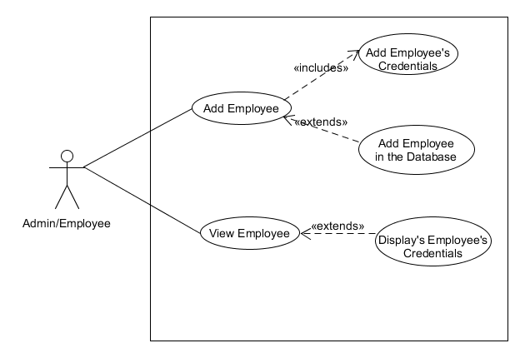

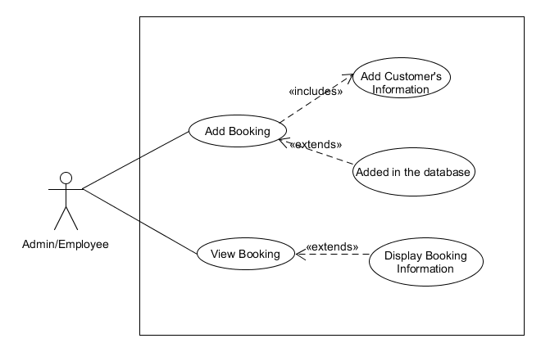

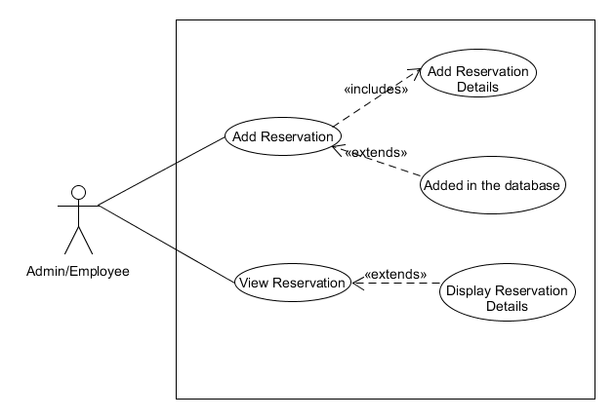

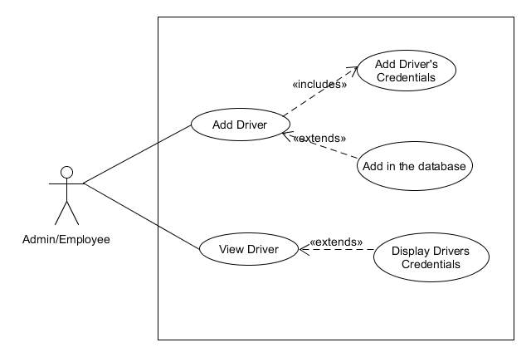

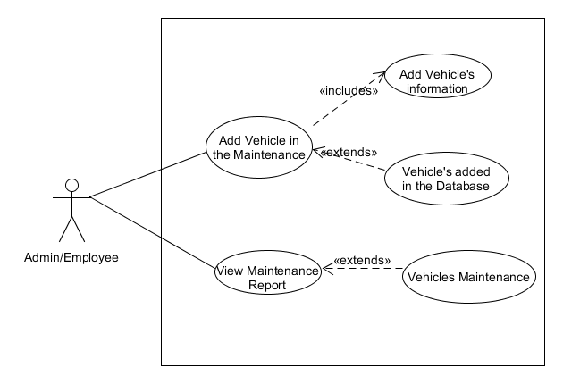

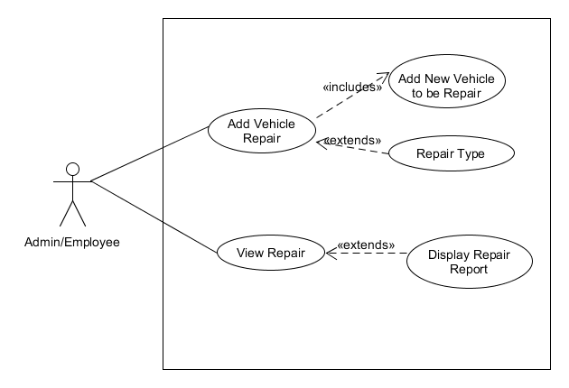

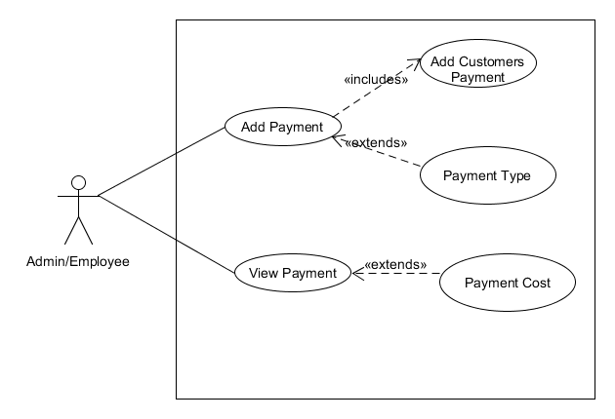

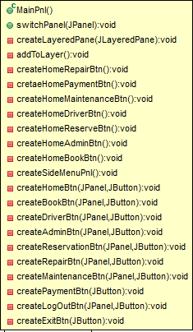 **CLASS DIAGRAM**

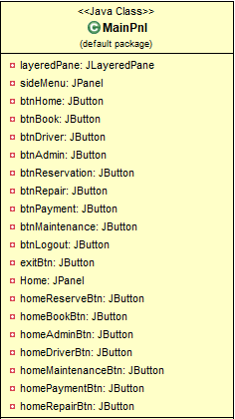

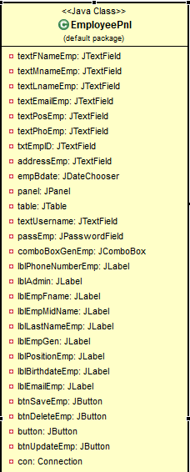

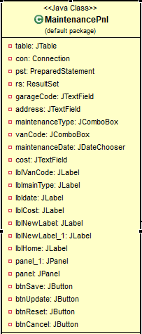

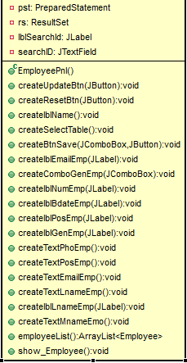

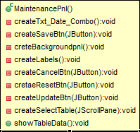

MainPnl

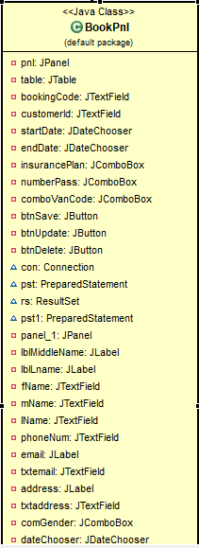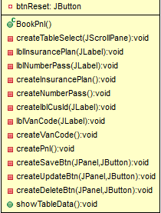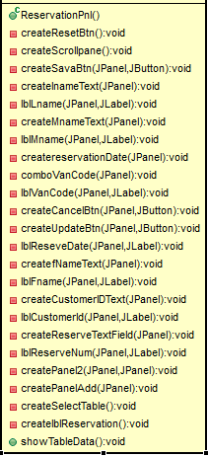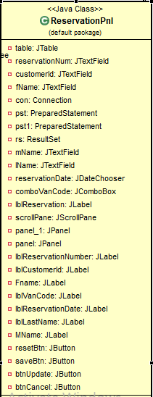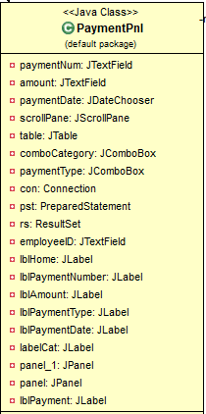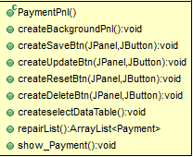

MainPnl

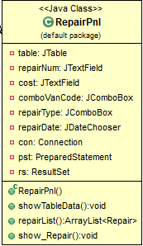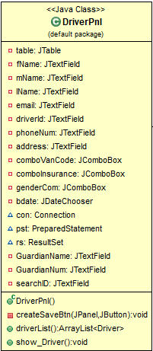

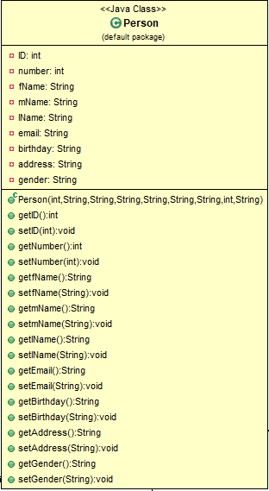

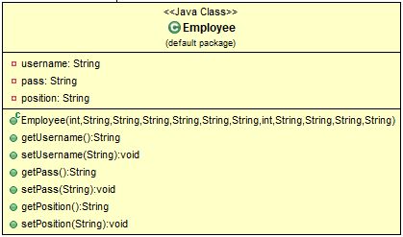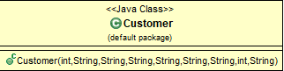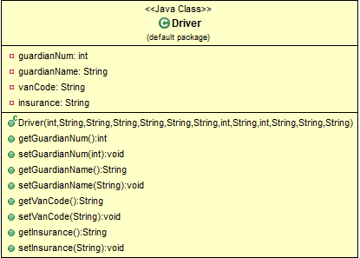

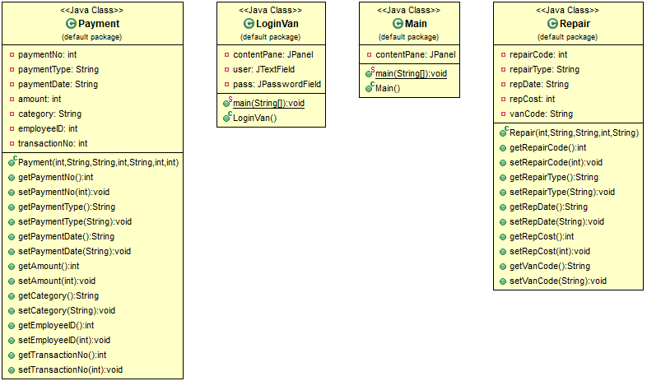

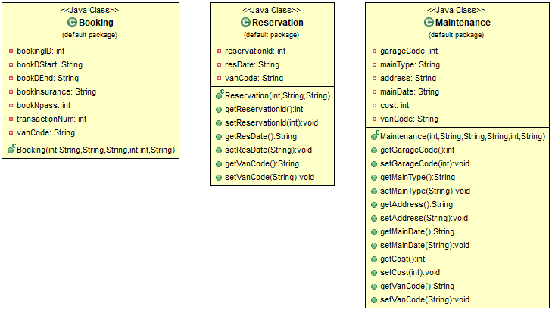

**SEQUENCE DIAGRAM**

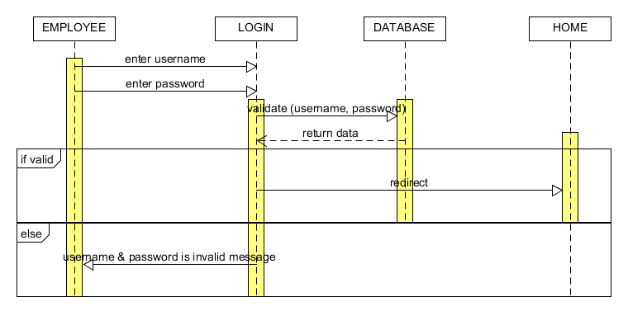LOGIN

EMPLOYEE

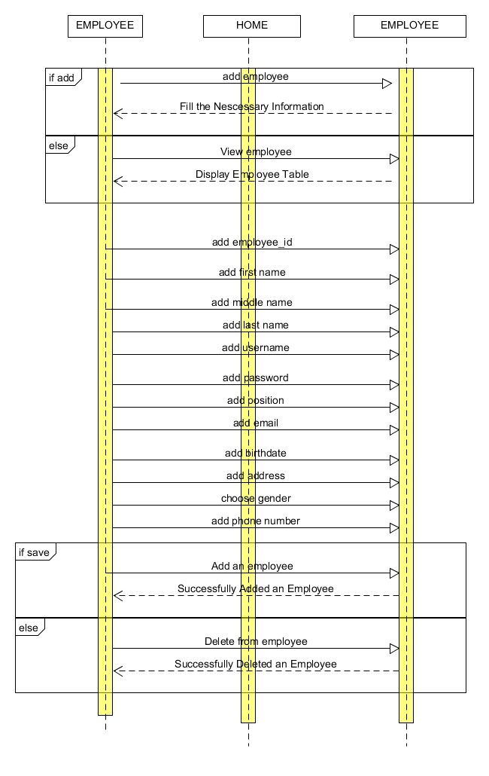

BOOKING

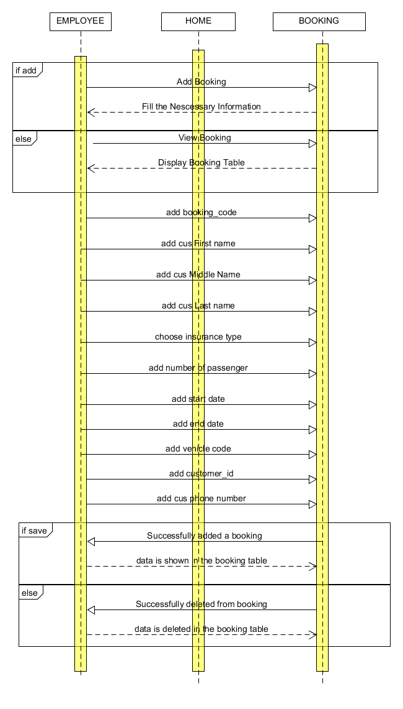

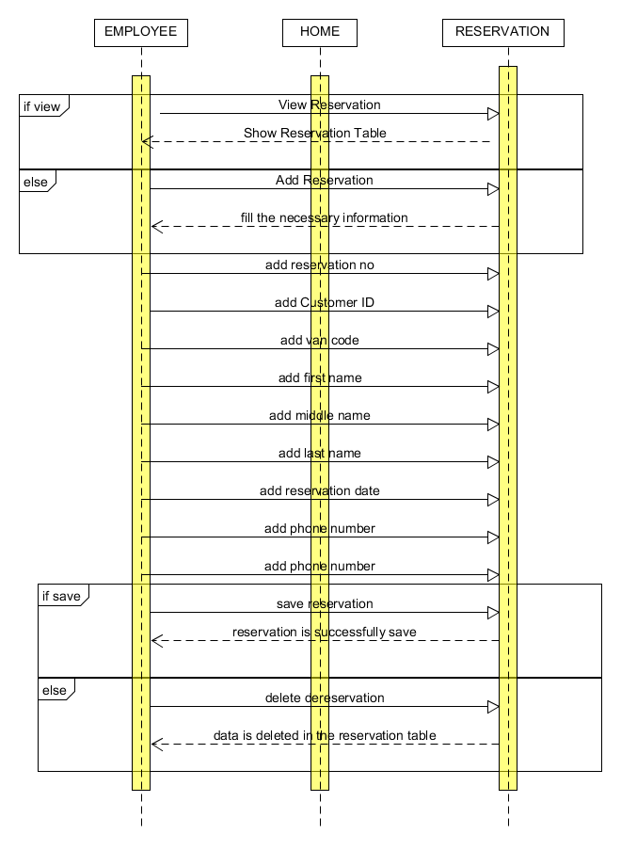RESERVATION

DRIVER

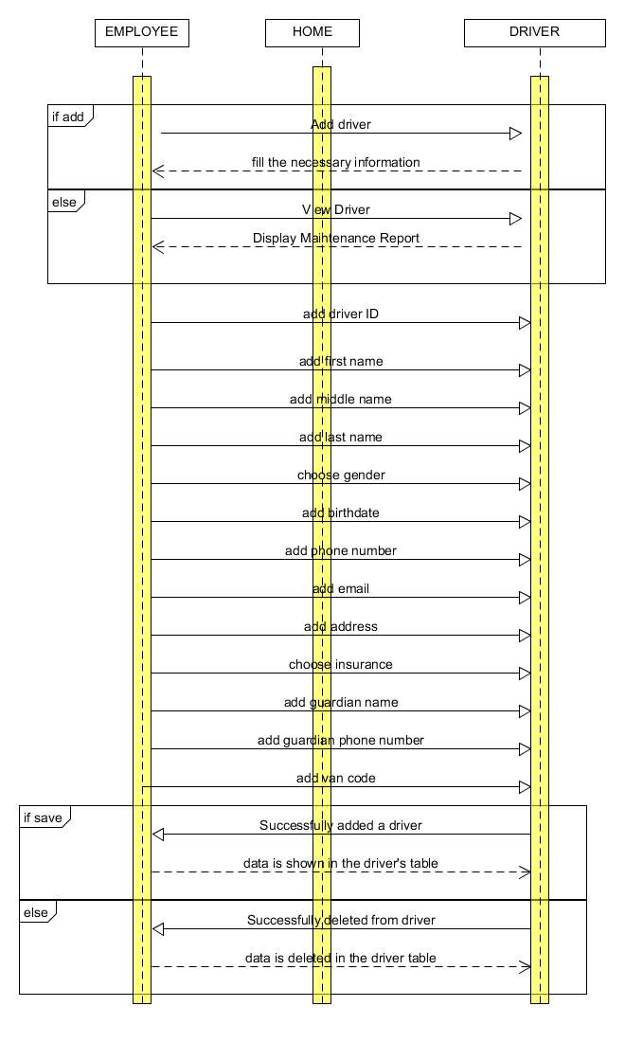

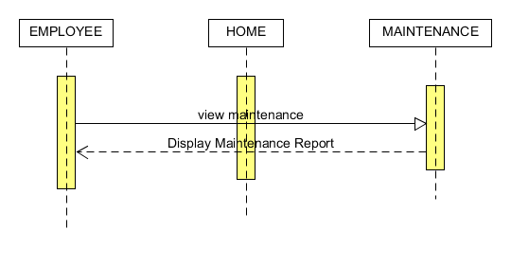MAINTENANCE

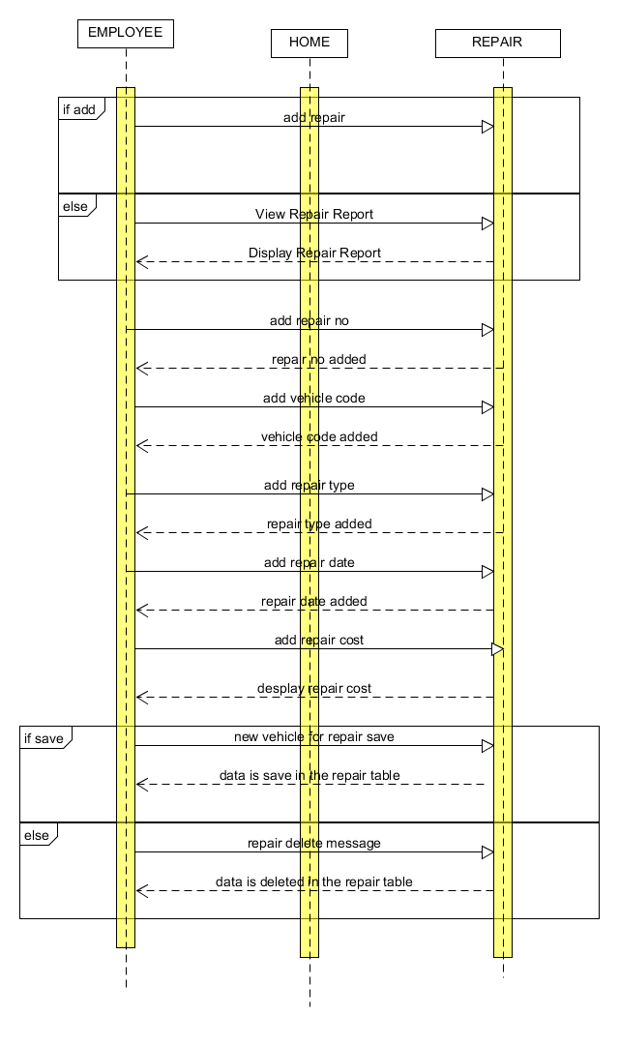REPAIR

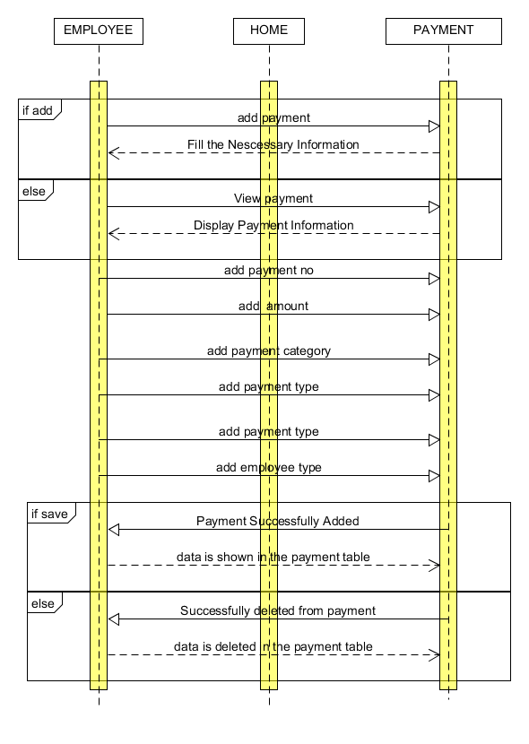PAYMENT